Welcome To
Trinity Lutheran Church
Lutheran Church—Missouri Synod
A Stephen Ministry Congregation

1354 South Otsego Avenue
Gaylord, Michigan 49735
Church Phone: (989) 732-4816

Church Email: secretary@trinitygaylord.com
www.trinitygaylord.com

Office Hours: Monday through Friday 9am – 1pm

OUR PURPOSE
…is to LOVE GOD, LOVE OTHERS, AND SERVE THE WORLD by worshiping the Lord Jesus, bringing our members into Christ-like maturity, and equipping them through Word and Sacrament for their mission and ministry. We go heart to heart into the world with Jesus, sharing His love, caring for one another, praying, and bringing the lost into a relationship with Christ, by the working of the Holy Spirit.

December 4, 2022
Second Sunday in Advent
Preacher: Rev. Paul Schneider

ABOUT OUR WORSHIP
We welcome all who gather here today! We are blessed to celebrate together the mercy, grace, and love we have from God through the death and resurrection of our Lord Jesus Christ.

Children: Families with children are very welcome here. Having children in church is important so they can begin to learn about their faith in Jesus, and it’s good for the whole congregation to see. Please feel comfortable keeping “squirmy” kids in the service. This is where they belong, too!

Pew Cards: Guests and Members, please fill out the Guest/Member card located on the back of the pew in front of you and pass it to the end of the aisle. If you forget you can put it in the offering plate on your way out.

If standing is difficult: Please feel free to remain seated during any portion of the service. Please let an Elder or Usher know if you need communion in your pew seat.

About our celebration of Holy Communion: We celebrate the Lord’s Supper in the confession and glad confidence that, as he says, our Lord gives into our mouths not only bread and wine but his very body and blood to eat and to drink for the forgiveness of sins and to strengthen our union with him and with one another. Our Lord invites to his table those who trust his words, repent of all sin, and set aside any refusal to forgive and love as he forgives and loves us, that they may show forth his death until he comes.
Because those who eat and drink our Lord’s body and blood contrary to that which is stated above do so to their great harm, and also because Holy Communion is a confession of the faith which is confessed at this altar. Anyone who is not yet instructed, in doubt, or who hold a confession differing from that of the Lutheran Church—Missouri Synod, and yet desire to receive the sacrament, are asked first to speak with Pastor. Those not communing are still invited to come forward for a blessing from Pastor, and you may indicate this by crossing your arms over your chest.
TTTTTT
GREETING
P Peace be with you.
C And also with you.
P Let us Pray
T ORDER OF SERVICE T
(The liturgy is from Divine Service Setting one LSB pg.151ff)

OPENING HYMN
Lo, How a Rose E’er Blooming LSB 359 sts. 1–2
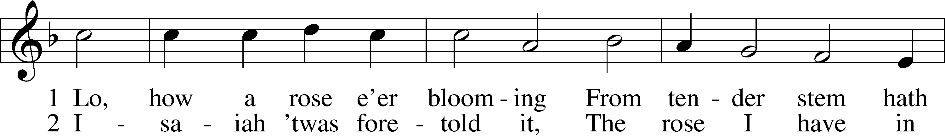
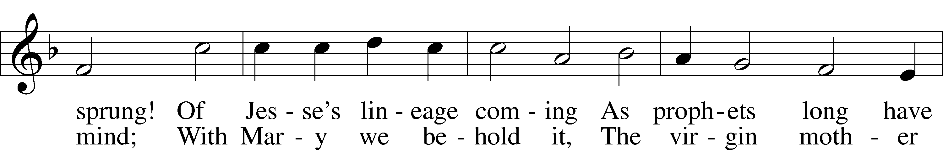
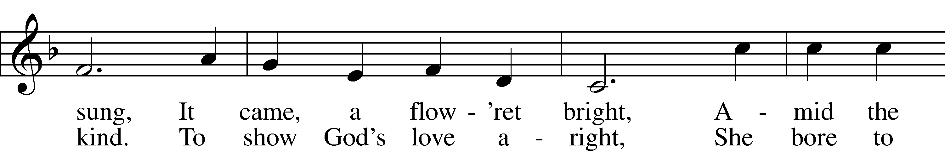
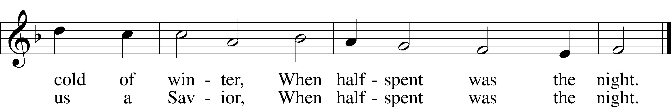

Please stand as able
CONFESSION and ABSOLUTION
The sign of the cross T may be made by all in remembrance of their Baptism.

P In the name of the Father and of the T Son and of the Holy Spirit.
C Amen.
P If we say we have no sin, we deceive ourselves, and the truth is not in us.
C But if we confess our sins, God, who is faithful and just, will forgive our sins and cleanse us from all unrighteousness.

Silence for reflection on God’s Word and for self-examination.

P Let us then confess our sins to God our Father.
C Most merciful God, we confess that we are by nature sinful and unclean. We have sinned against You in thought, word, and deed, by what we have done and by what we have left undone. We have not loved You with our whole heart; we have not loved our neighbors as ourselves. We justly deserve Your present and eternal punishment. For the sake of Your Son, Jesus Christ, have mercy on us. Forgive us, renew us, and lead us, so that we may delight in Your will and walk in Your ways to the glory of Your holy name. Amen.

P In the mercy of almighty God, Jesus Christ was given to die for us, and for His sake God forgives us all our sins. To those who believe in Jesus Christ He gives the power to become the children of God and bestows on them the Holy Spirit. May the Lord, who has begun this good work in us, bring it to completion in the day of our Lord Jesus Christ.
C Amen.

T SERVICE OF THE WORD T

KYRIE Pg. 152

P In peace let us pray to the Lord.
C Lord, have mercy.
P For the peace from above and for our salvation let us pray to the Lord.
C Lord, have mercy.
P For the peace of the whole world, for the well-being of the Church of God, and for the unity of all let us pray to the Lord.
C Lord, have mercy.
P For this holy house and for all who offer here their worship and praise let us pray to the Lord.
C Lord, have mercy.
P Help, save, comfort, and defend us, gracious Lord.
C Amen.

HYMN OF PRAISE
This Is the Feast LSB 155
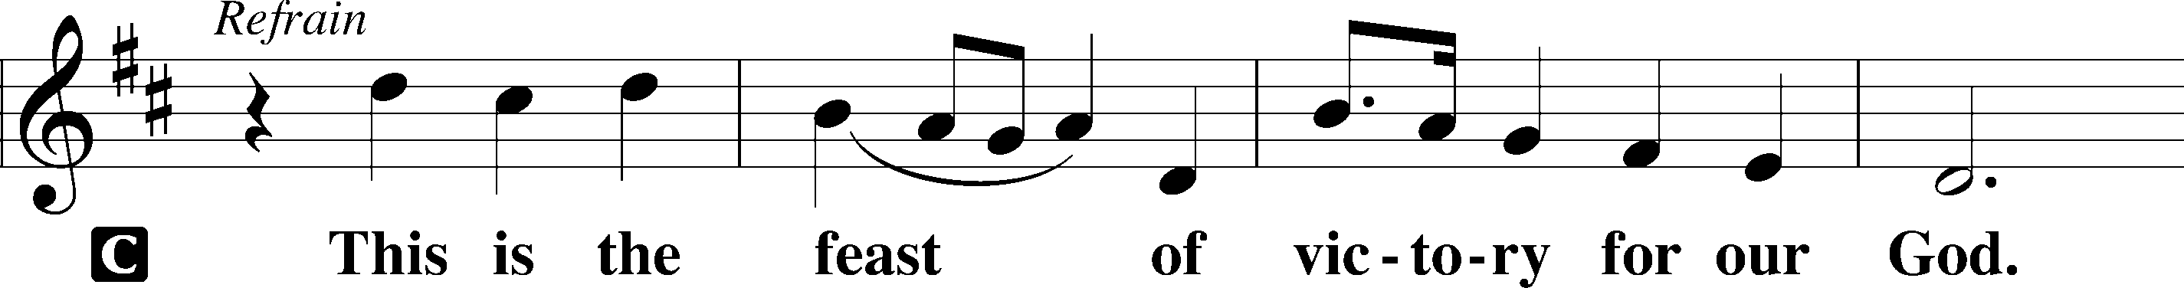
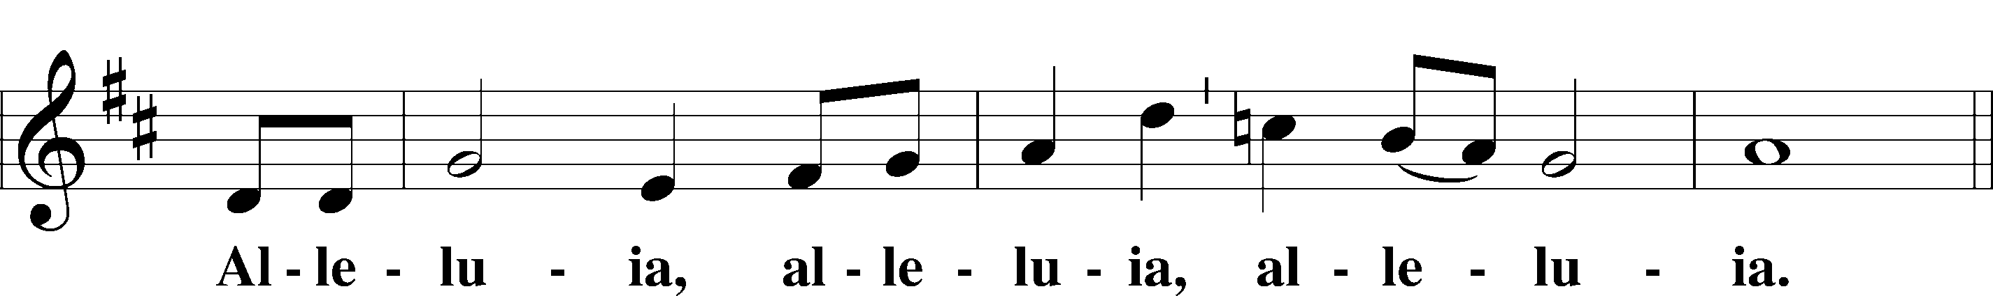
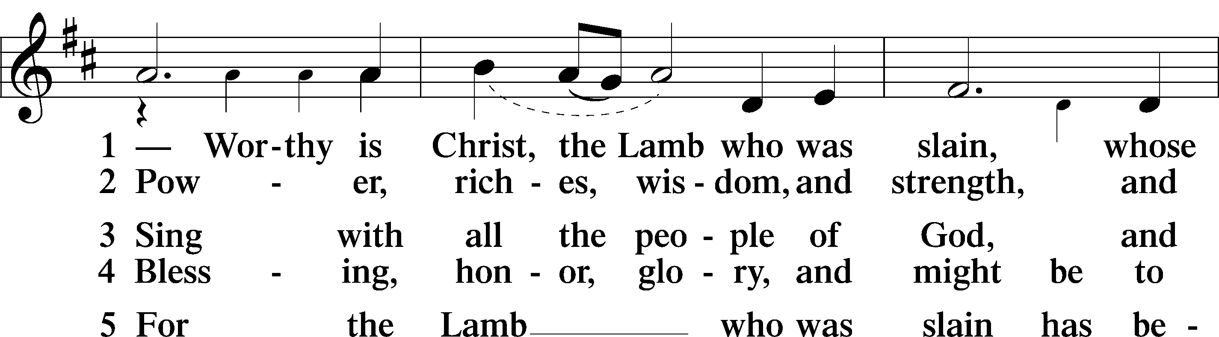
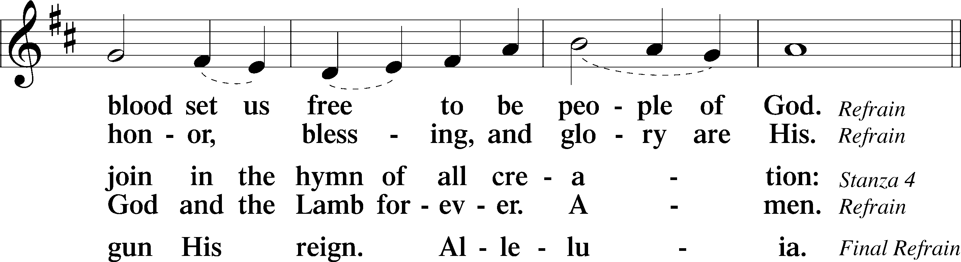
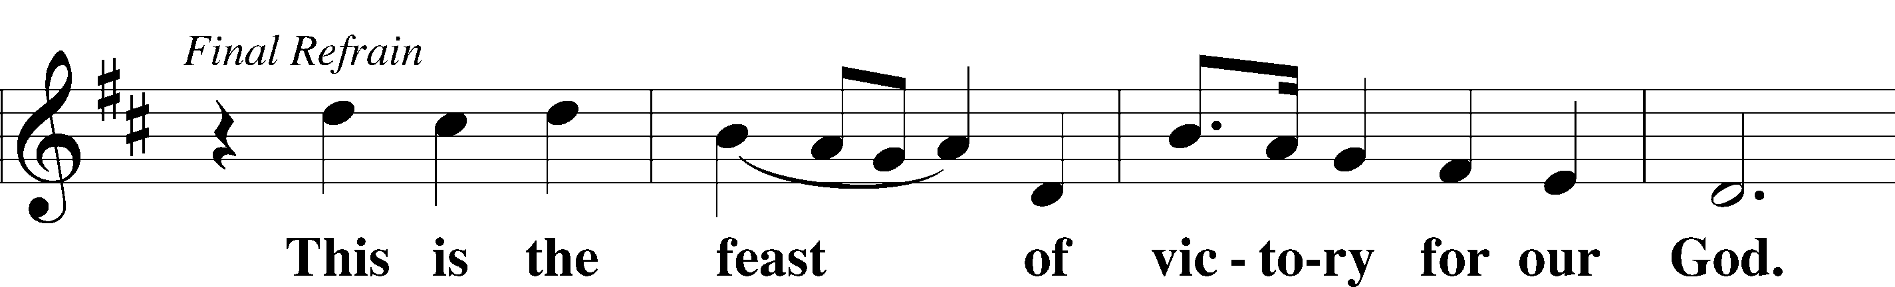
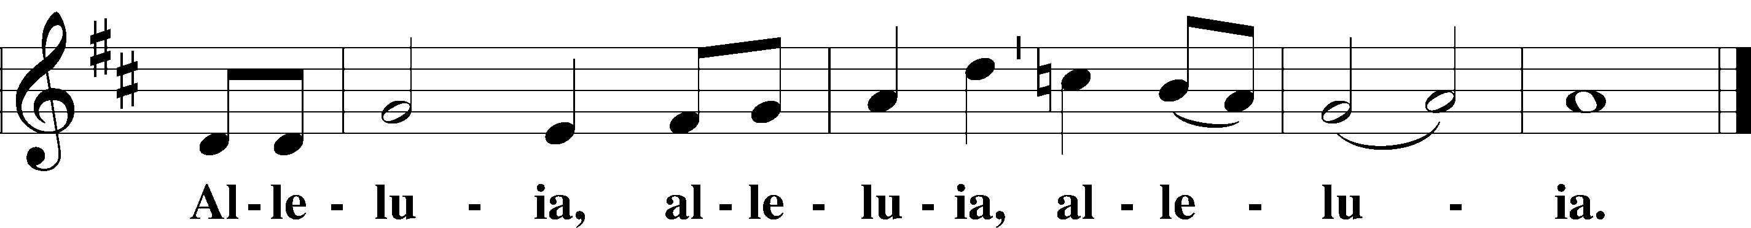

SALUTATION AND COLLECT OF THE DAY
P The Lord be with you.
C And also with you.
P Let us pray.
Stir up our hearts, O Lord, to make ready the way of Your only-begotten Son, that by His coming we may be enabled to serve You with pure minds; through the same Jesus Christ, our Lord, who lives and reigns with You and the Holy Spirit, one God, now and forever.
C Amen.

Please be seated

OLD TESTAMENT Isaiah 11:1–10
¹There shall come forth a shoot from the stump of Jesse,
and a branch from his roots shall bear fruit.
²And the Spirit of the Lord shall rest upon him,
the Spirit of wisdom and understanding,
the Spirit of counsel and might,
the Spirit of knowledge and the fear of the Lord.
³And his delight shall be in the fear of the Lord.
He shall not judge by what his eyes see,
or decide disputes by what his ears hear,
⁴but with righteousness he shall judge the poor,
and decide with equity for the meek of the earth;
and he shall strike the earth with the rod of his mouth,
and with the breath of his lips he shall kill the wicked.
⁵Righteousness shall be the belt of his waist,
and faithfulness the belt of his loins.
⁶The wolf shall dwell with the lamb,
and the leopard shall lie down with the young goat,
and the calf and the lion and the fattened calf together;
and a little child shall lead them.
⁷The cow and the bear shall graze;
their young shall lie down together;
and the lion shall eat straw like the ox.
⁸The nursing child shall play over the hole of the cobra,
and the weaned child shall put his hand on the adder’s den.
⁹They shall not hurt or destroy
in all my holy mountain;
for the earth shall be full of the knowledge of the Lord
as the waters cover the sea.
¹⁰In that day the root of Jesse, who shall stand as a signal for the peoples—of him shall the nations inquire, and his resting place shall be glorious.

P This is the Word of the Lord.
C Thanks be to God.

EPISTLE Romans 15:4–13
⁴Whatever was written in former days was written for our instruction, that through endurance and through the encouragement of the Scriptures we might have hope. ⁵May the God of endurance and encouragement grant you to live in such harmony with one another, in accord with Christ Jesus, ⁶that together you may with one voice glorify the God and Father of our Lord Jesus Christ. ⁷Therefore welcome one another as Christ has welcomed you, for the glory of God.
⁸For I tell you that Christ became a servant to the circumcised to show God’s truthfulness, in order to confirm the promises given to the patriarchs, ⁹and in order that the Gentiles might glorify God for his mercy. As it is written,
“Therefore I will praise you among the Gentiles,
and sing to your name.”
¹⁰And again it is said,
“Rejoice, O Gentiles, with his people.”
¹¹And again,
“Praise the Lord, all you Gentiles,
and let all the peoples extol him.”
¹²And again Isaiah says,
“The root of Jesse will come,
even he who arises to rule the Gentiles;
in him will the Gentiles hope.”
¹³May the God of hope fill you with all joy and peace in believing, so that by the power of the Holy Spirit you may abound in hope.
P This is the Word of the Lord.
C Thanks be to God.

Please stand as able

ALLELUIA AND VERSE LSB 156
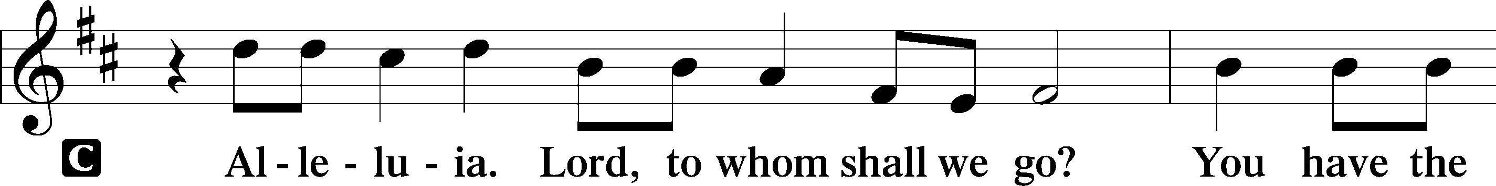
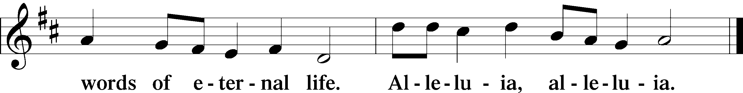

HOLY GOSPEL Matthew 3:1–12
P The Holy Gospel according to St. Matthew, the third chapter.
C Glory to You, O Lord.

¹In those days John the Baptist came preaching in the wilderness of Judea, ²“Repent, for the kingdom of heaven is at hand.” ³For this is he who was spoken of by the prophet Isaiah when he said,
“The voice of one crying in the wilderness:
‘Prepare the way of the Lord;
make his paths straight.’”
⁴Now John wore a garment of camel’s hair and a leather belt around his waist, and his food was locusts and wild honey. ⁵Then Jerusalem and all Judea and all the region about the Jordan were going out to him, ⁶and they were baptized by him in the river Jordan, confessing their sins.
⁷But when he saw many of the Pharisees and Sadducees coming for baptism, he said to them, “You brood of vipers! Who warned you to flee from the wrath to come? ⁸Bear fruit in keeping with repentance. ⁹And do not presume to say to yourselves, ‘We have Abraham as our father,’ for I tell you, God is able from these stones to raise up children for Abraham. ¹⁰Even now the axe is laid to the root of the trees. Every tree therefore that does not bear good fruit is cut down and thrown into the fire.
¹¹“I baptize you with water for repentance, but he who is coming after me is mightier than I, whose sandals I am not worthy to carry. He will baptize you with the Holy Spirit and with fire. ¹²His winnowing fork is in his hand, and he will clear his threshing floor and gather his wheat into the barn, but the chaff he will burn with unquenchable fire.”

P This is the Gospel of the Lord.
C Praise to You, O Christ.

NICENE CREED
C I believe in one God,
the Father Almighty,
maker of heaven and earth
and of all things visible and invisible.
And in one Lord Jesus Christ,
the only-begotten Son of God,
begotten of His Father before all worlds,
God of God, Light of Light,
very God of very God,
begotten, not made,
being of one substance with the Father,
by whom all things were made;
who for us men and for our salvation came down from heaven
and was incarnate by the Holy Spirit of the virgin Mary
and was made man;
and was crucified also for us under Pontius Pilate.
He suffered and was buried.
And the third day He rose again according to the Scriptures
and ascended into heaven
and sits at the right hand of the Father.
And He will come again with glory to judge both the living and the dead,
whose kingdom will have no end.
And I believe in the Holy Spirit,
the Lord and giver of life,
who proceeds from the Father and the Son,
who with the Father and the Son together is worshiped and glorified,
who spoke by the prophets.
And I believe in one holy Christian and apostolic Church,
I acknowledge one Baptism for the remission of sins,
and I look for the resurrection of the dead
and the life T of the world to come. Amen.

Please be seated

ALL GOD’S CHILDREN – TALK

SERMON HYMN
I Want to Walk as a Child of the Light LSB 411
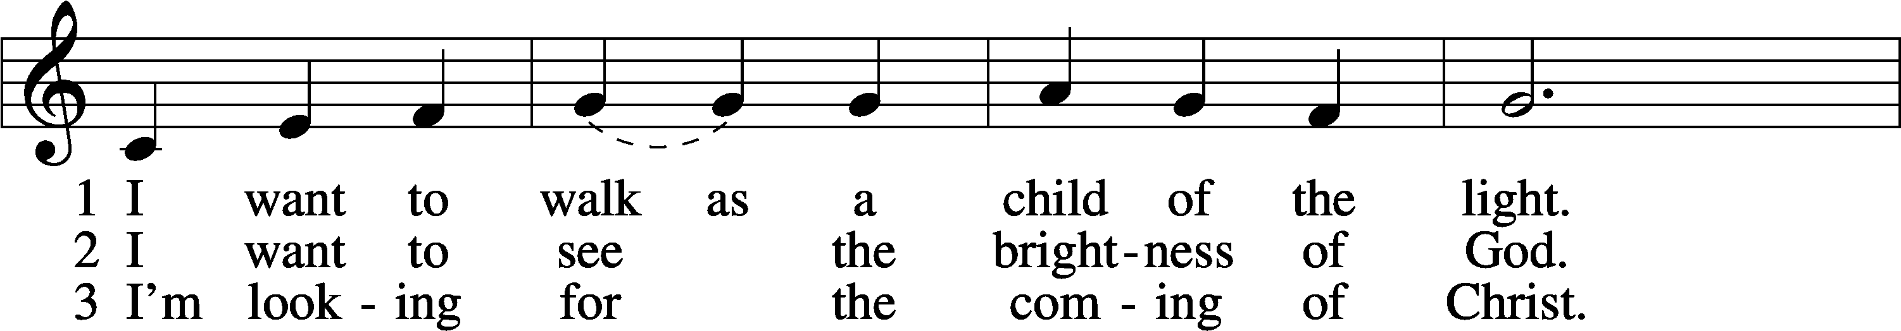
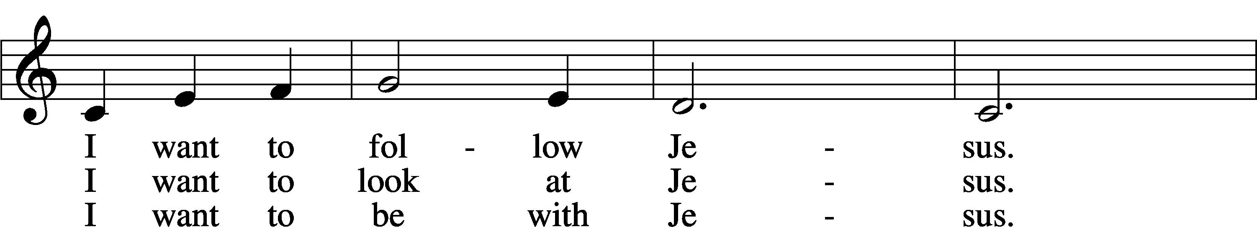
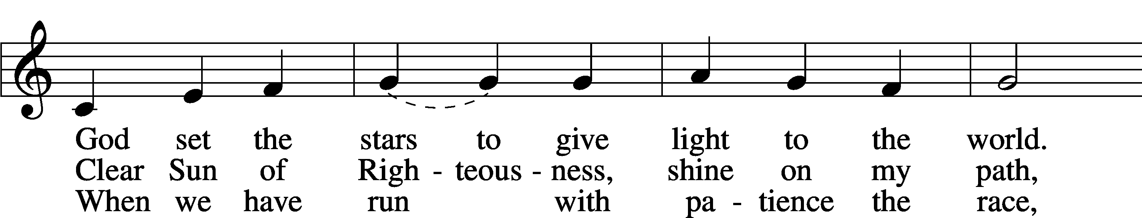
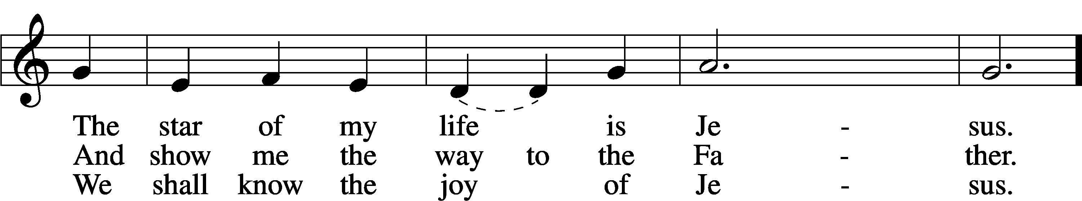
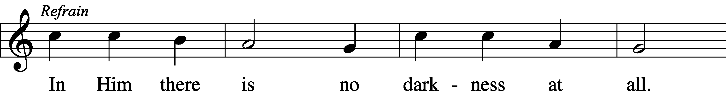
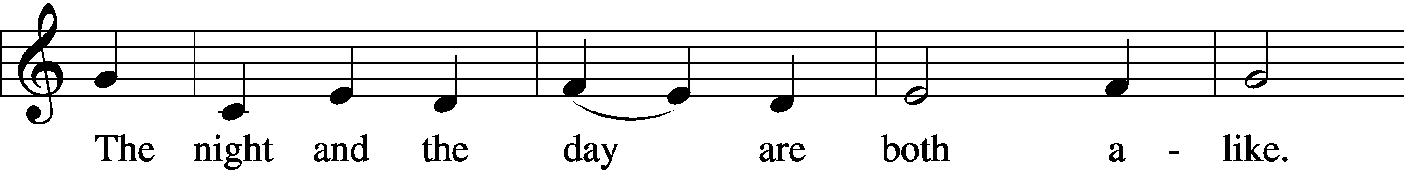
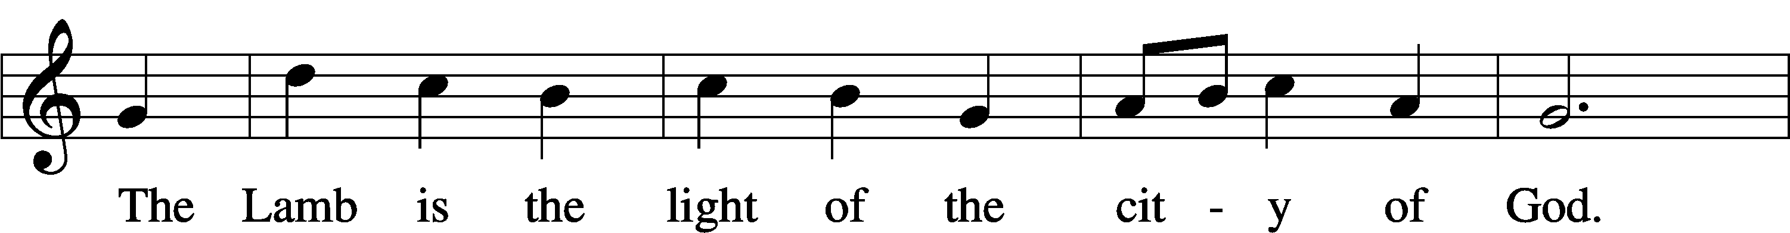
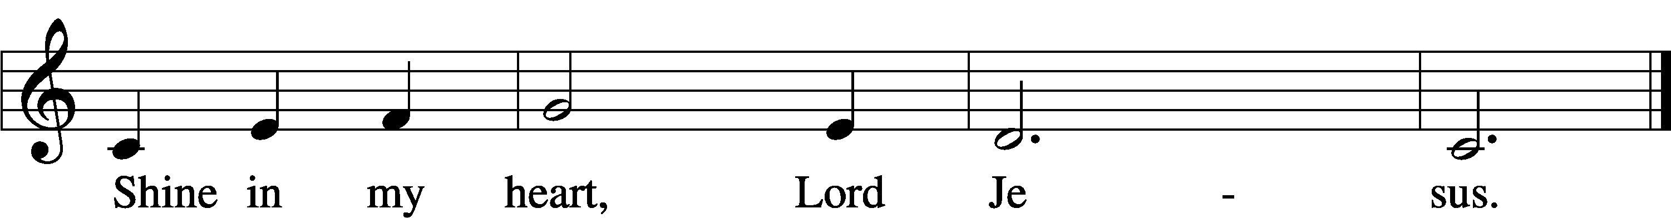

SERMON

Please stand as able

PRAYER of the CHURCH
After each Segment:
P Lord, in Your Mercy,
C Hear our Prayer.
After Final Segment:
P Hear us as we pray in His name and as He has taught us:
LORD’S PRAYER
C Our Father who art in heaven,
hallowed be Thy name,
Thy kingdom come,
Thy will be done on earth
as it is in heaven;
give us this day our daily bread;
and forgive us our trespasses
as we forgive those
who trespass against us;
and lead us not into temptation,
but deliver us from evil.
For Thine is the kingdom
and the power and the glory
forever and ever. Amen.

T SERVICE of the SACRAMENT T

PREFACE LSB 160
P The Lord be with you.
C And also with you.

P Lift up your hearts.
C We lift them to the Lord.

P Let us give thanks to the Lord our God.
C It is right to give Him thanks and praise.

P It is truly good, right, and salutary that we should at all times and in all places give thanks to You, O Lord, holy Father, almighty and everlasting God, for the countless blessings You so freely bestow on us and all creation. Above all, we give thanks for Your boundless love shown to us when You sent Your only-begotten Son, Jesus Christ, into our flesh and laid on Him our sin, giving Him into death that we might not die eternally. Because He is now risen from the dead and lives and reigns to all eternity, all who believe in Him will overcome sin and death and will rise again to new life. Therefore with angels and archangels and with all the company of heaven we laud and magnify Your glorious name, evermore praising You and singing:

SANCTUS LSB 161
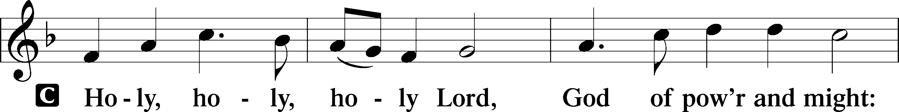
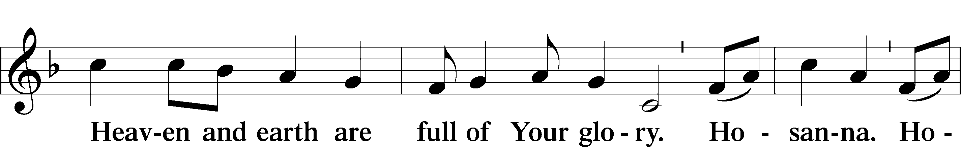
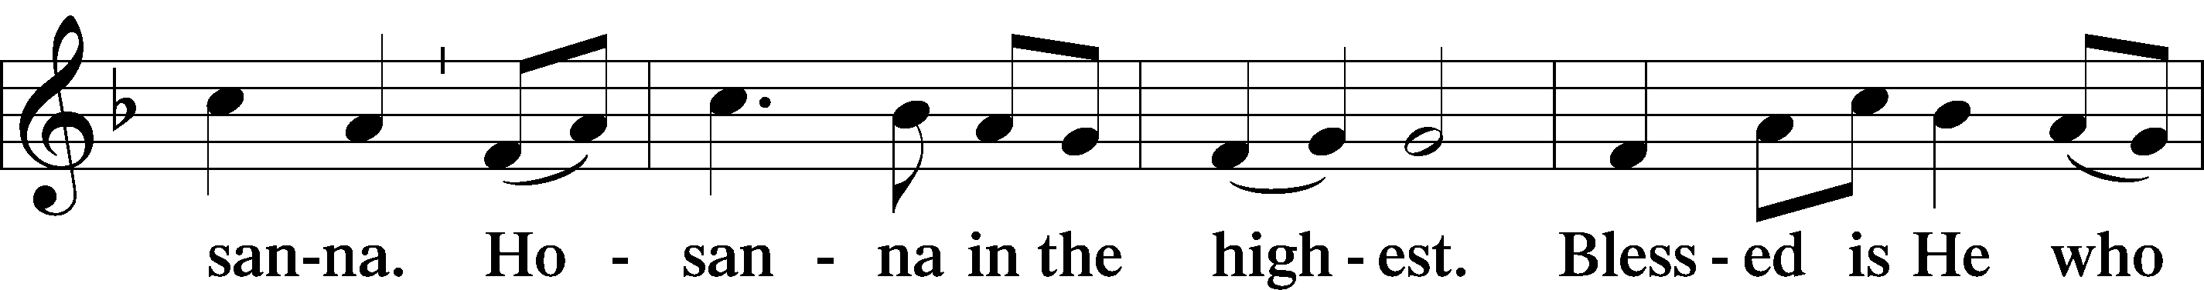
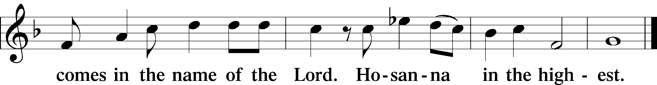

THE WORDS OF OUR LORD
P Our Lord Jesus Christ, on the night when He was betrayed, took bread, and when He had given thanks, He broke it and gave it to the disciples and said: “Take, eat; this is My T body, which is given for you. This do in remembrance of Me.”
In the same way also, He took the cup after supper, and when He had given thanks, He gave it to them, saying: “Drink of it, all of you; this cup is the New Testament in My T blood, which is shed for you for the forgiveness of sins. This do, as often as you drink it, in remembrance of Me.”

PAX DOMINI
P The peace of the Lord be with you always.
C Amen.
AGNUS DEI LSB 163
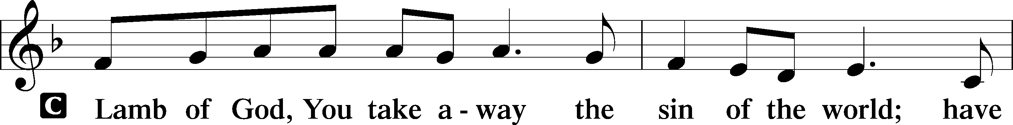
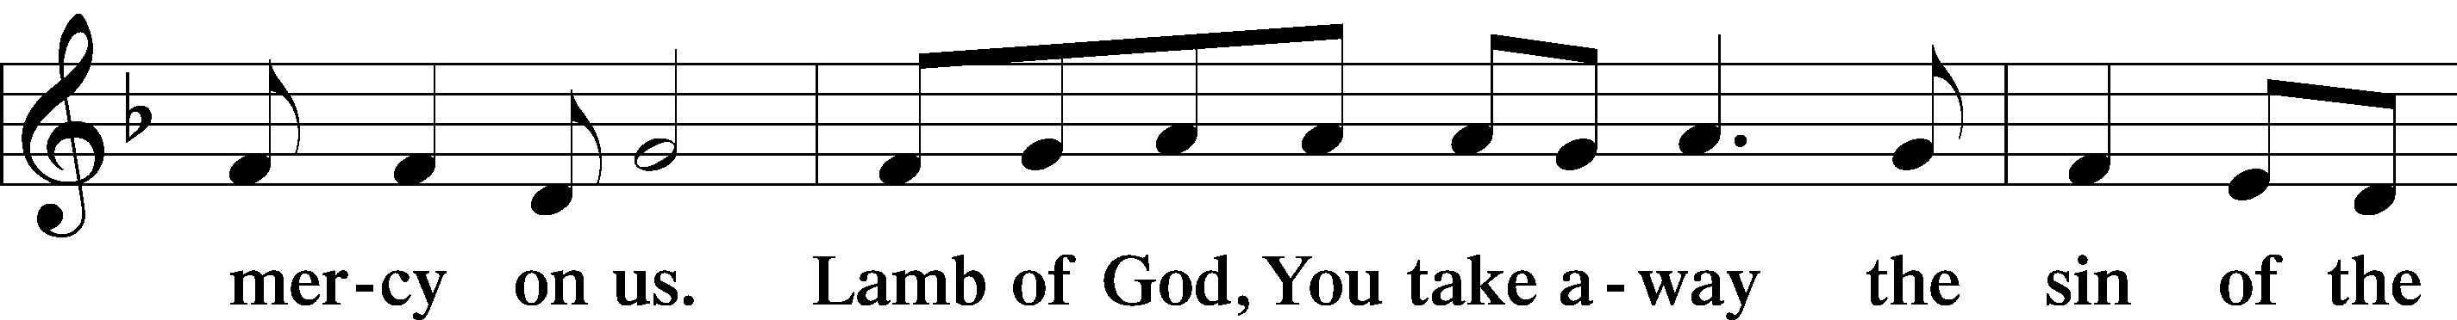
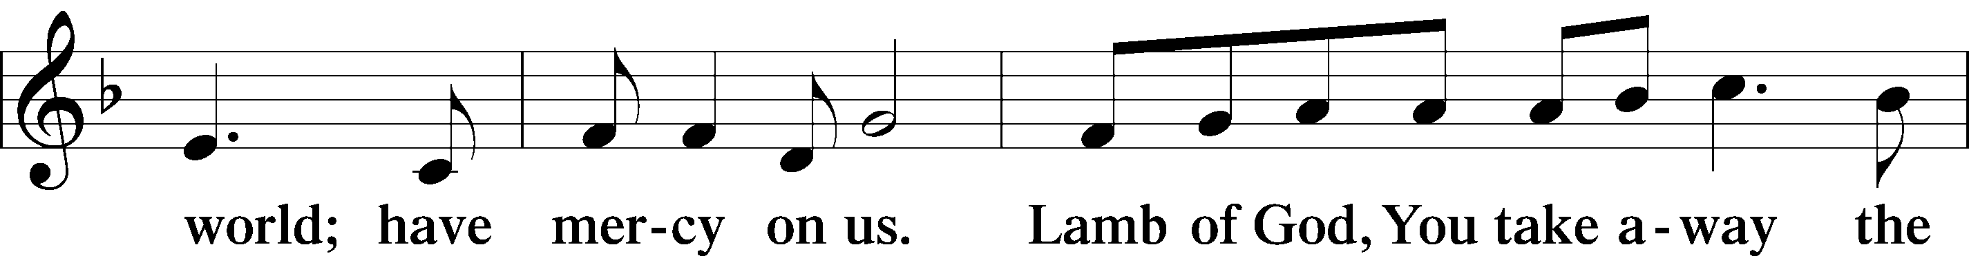
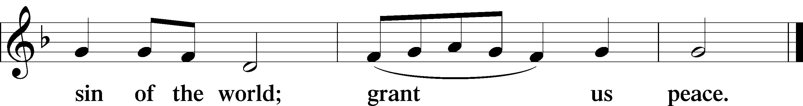
Please be seated

DISTRIBUTION
The pastor and those who assist him receive the body and blood of Christ first, then Communion will be served at the rail. Ushers will help direct you forward via the center aisle; please return to your seats via the side aisles. Gluten-free bread is available for those who need it, as is non-alcoholic grape juice. Simply request either when you come forward to receive Communion.
DISTRIBUTION HYMN
I Come O Savior, to Thy Table LSB 618
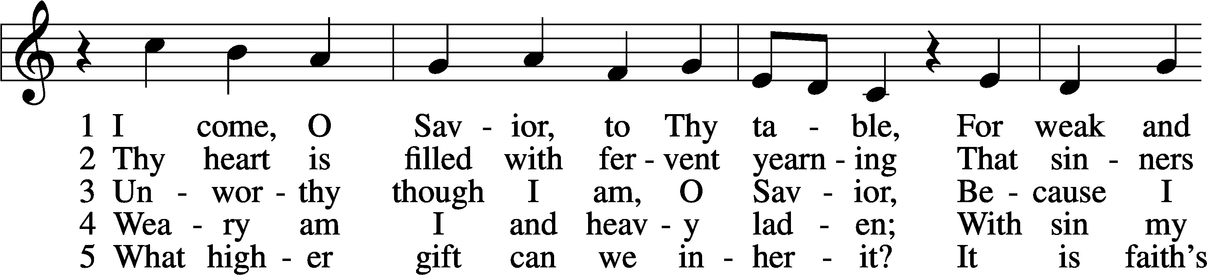
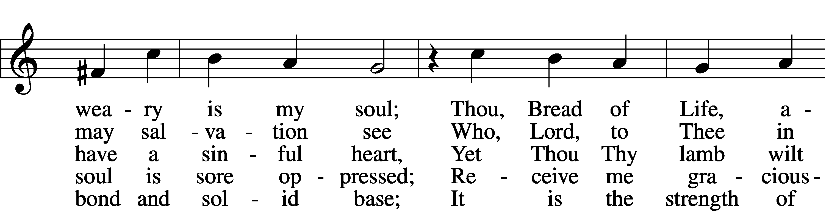
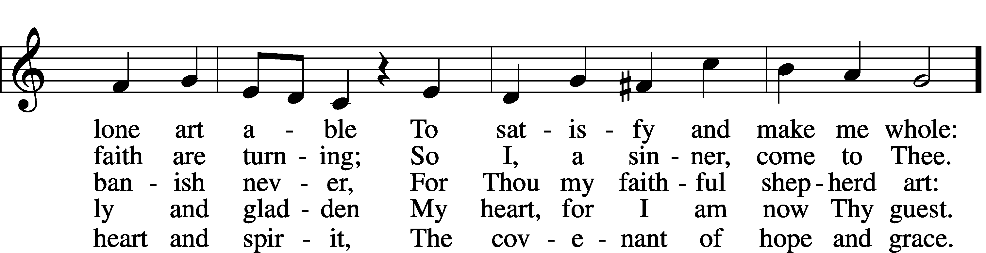
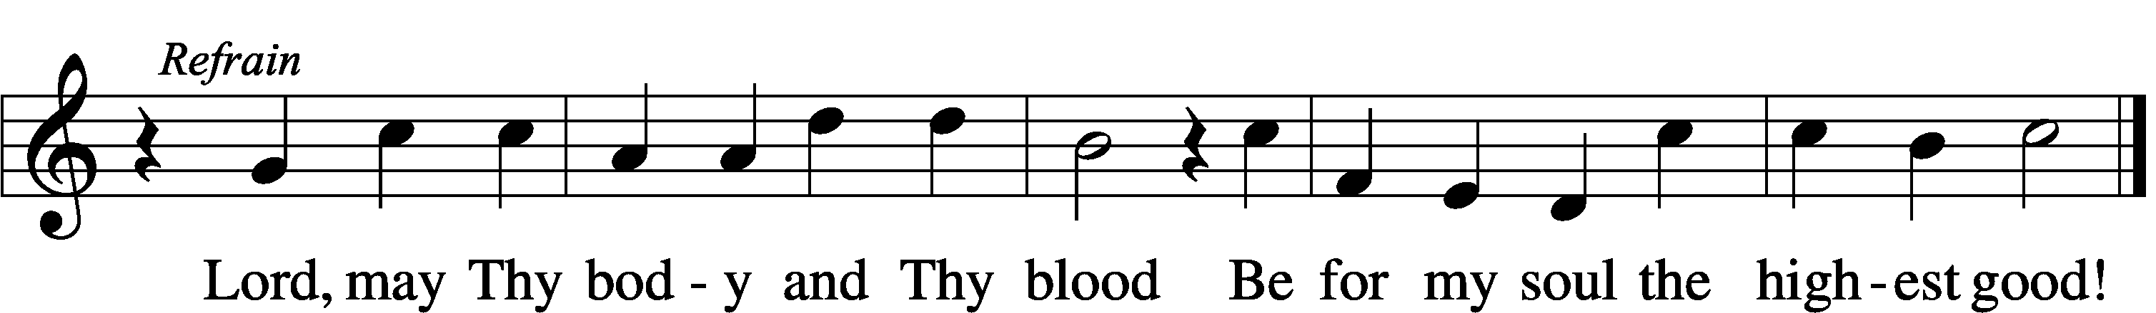

DISTRIBUTION HYMN
Your Table I Approach LSB 628 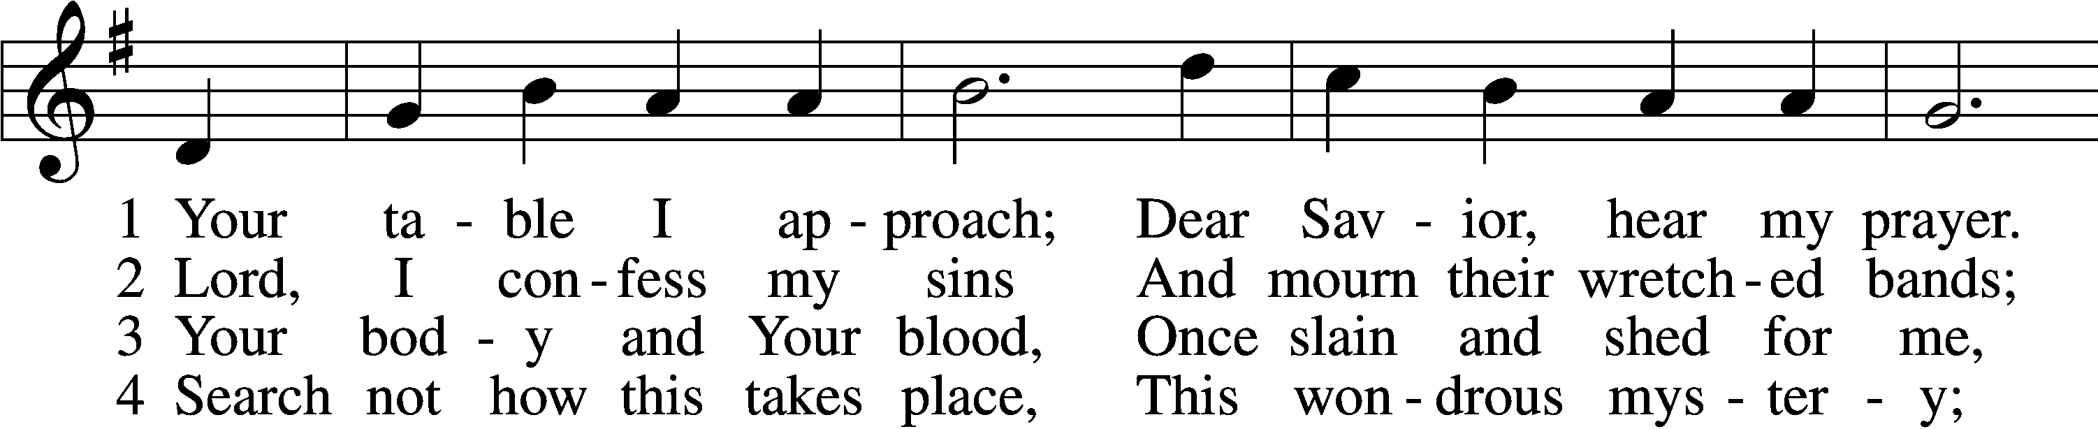
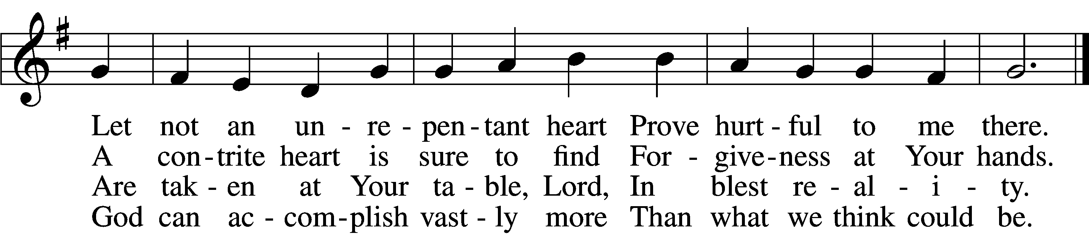

5 O grant, most lessed Lord,
That earth and hell combined
May not about this sacrament
Raise doubt within my mind.

6 Oh, may I never fail
To thank You day and night
For Your true body and true blood,
O God, my peace and light.

Please stand as able

POST COMMUNION CANTICLE
Thank the Lord LSB 164
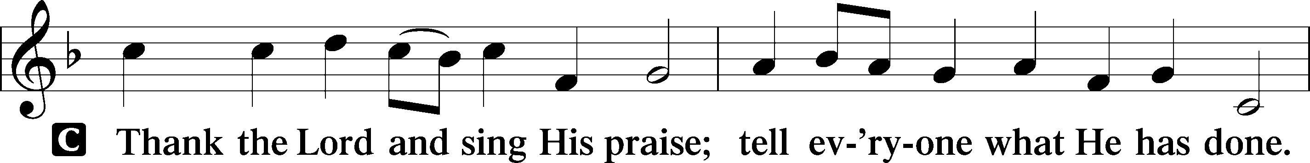
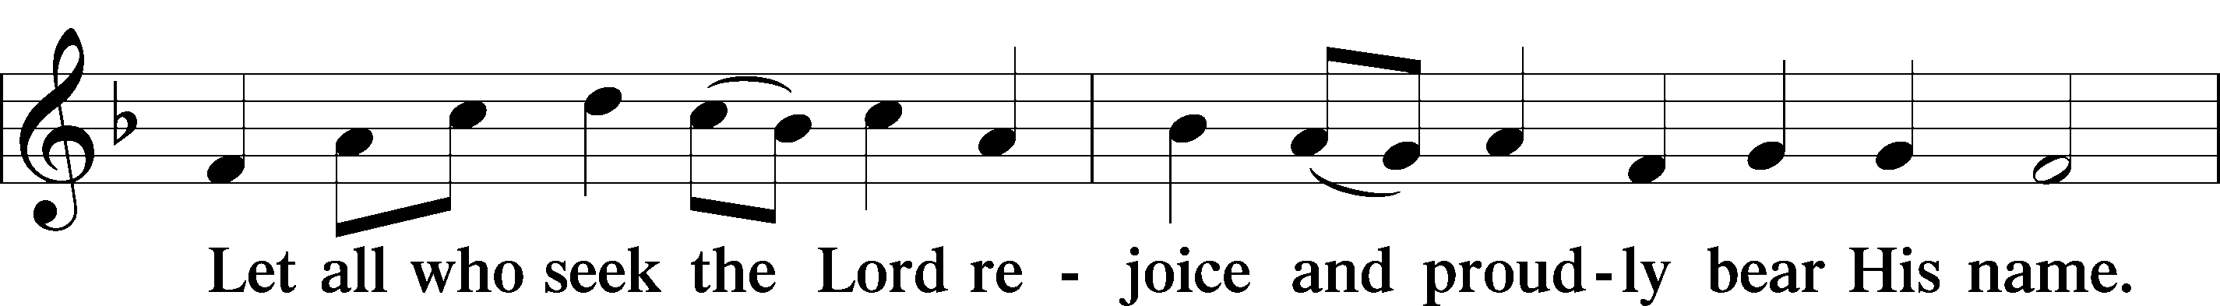
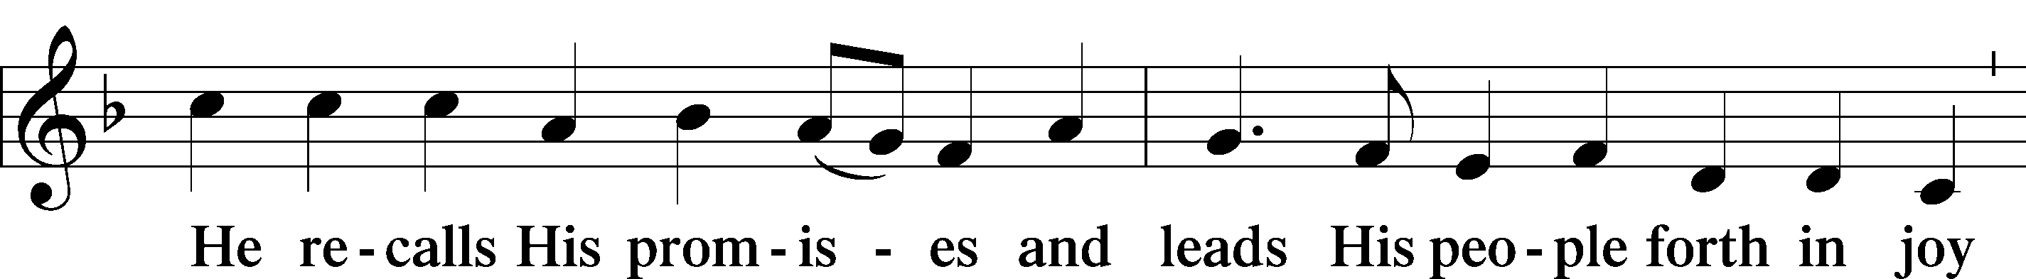
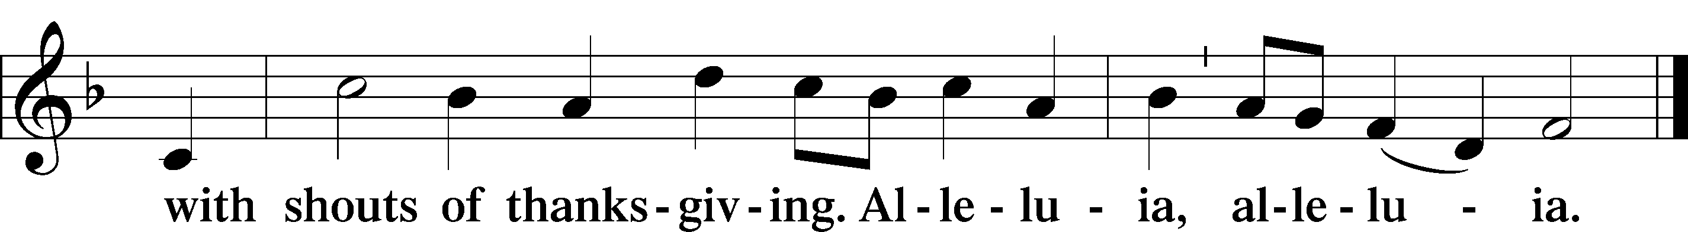
POST COMMUNION COLLECT
P Let us pray.
O God the Father, the fountain and source of all goodness, who in loving-kindness sent Your only-begotten Son into the flesh, we thank You that for His sake You have given us pardon and peace in this Sacrament, and we ask You not to forsake Your children but always to rule our hearts and minds by Your Holy Spirit that we may be enabled constantly to serve You; through Jesus Christ, Your Son, our Lord, who lives and reigns with You and the Holy Spirit, one God, now and forever.
C Amen.

BENEDICTION
P The Lord bless you and keep you.
The Lord make His face shine on you and be gracious to you.
The Lord look upon you with favor and T give you peace.
C Amen.

Please be seated
CLOSING HYMN
Lo, How a Rose E’er Blooming LSB 359 sts.3-4
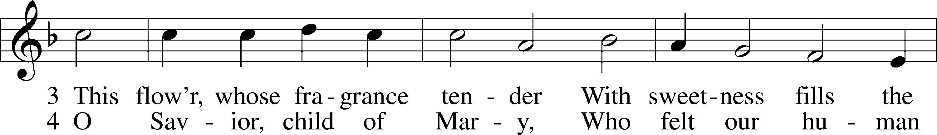
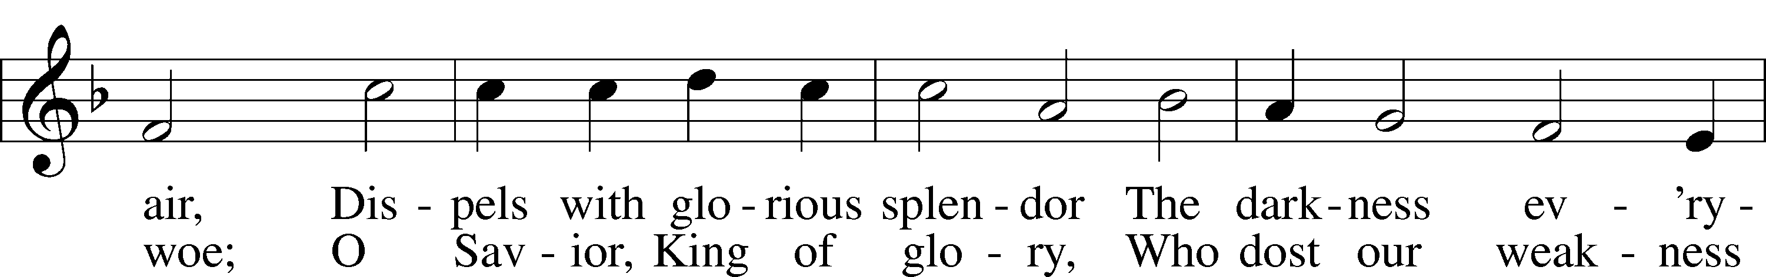
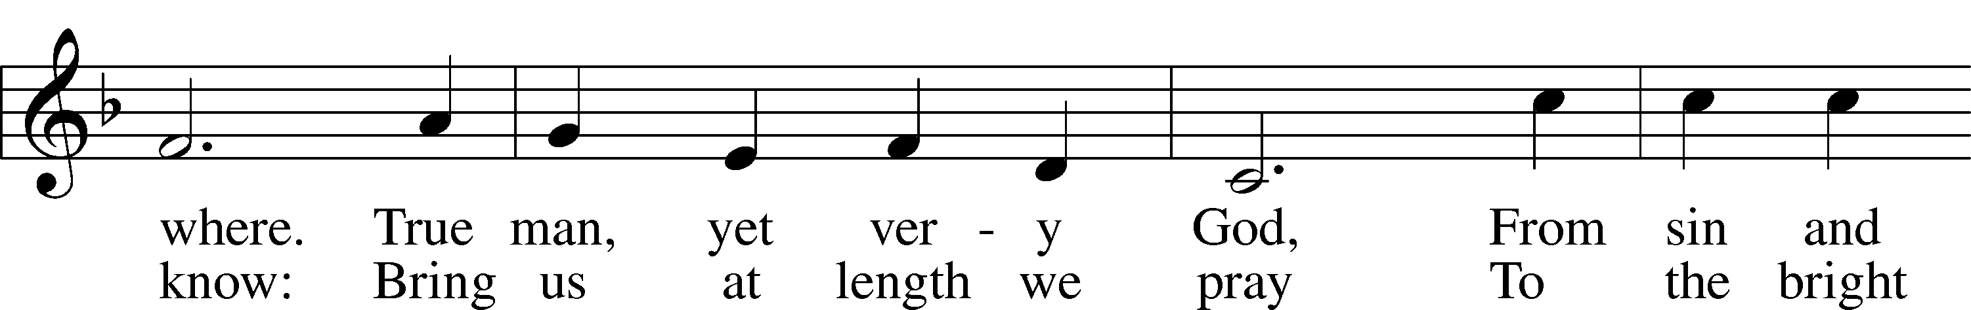
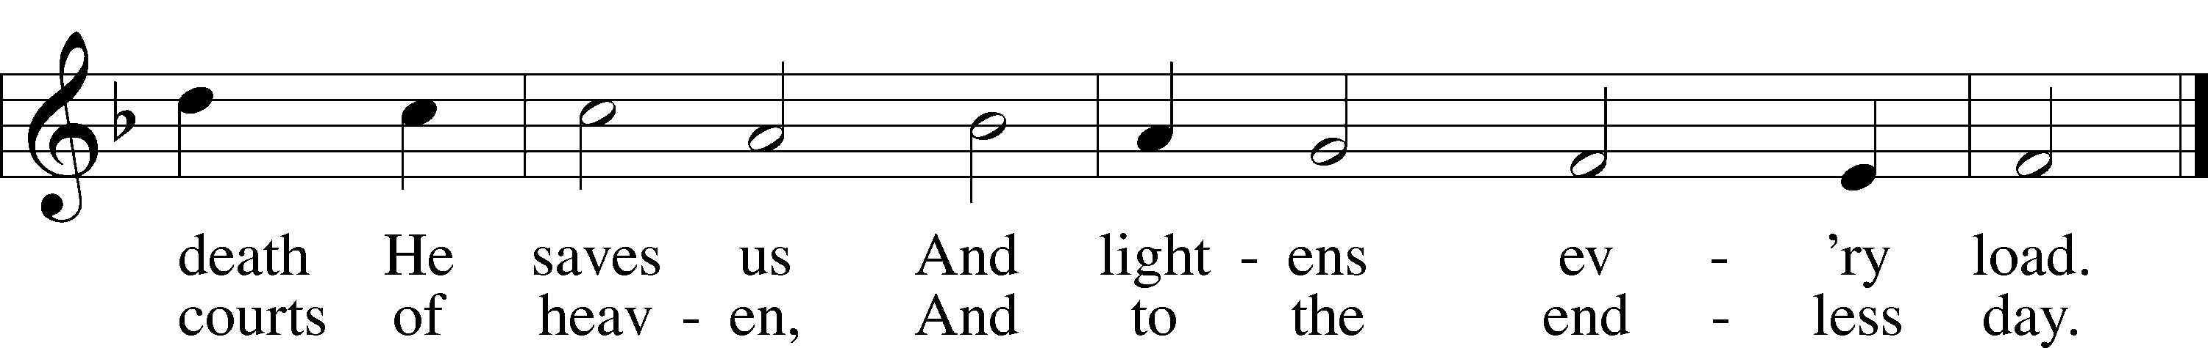

ANNOUNCEMENTS and SENDING WORDS
P We go to live for Jesus!
C We go to share His love!

Acknowledgments
Unless otherwise indicated, Scripture quotations are from the ESV® Bible (The Holy Bible, English Standard Version®), copyright 2001 by Crossway, a publishing ministry of Good News Publishers. Used by permission. All rights reserved. Created by Lutheran Service Builder. Music reproduced in this service is used with permission through: CCLI License No.1776588 and CPH – LSB Service Builder.

SERVING in GODS HOUSE TODAY
Pastor: Rev. Paul Schneider
Elder: Tim Arner
Ushers: Pam & Wally Beasinger
Greeters: Judi & John Stutzman
Coffee: Judi & John Stutzman
Counters: Donna Cottrell, LaVerne Scheiterlein
Altar Care: Terri Raithel
Virtual Organist: Bob Erat
Children’s Talk: Nancy Ely
PRAYERS
Please contact the office with updates to the prayer list. People will remain on the prayer list for 4 weeks before being removed. If they need to remain on the list, please keep Elaine informed and of any updates. This will help us to have a more accurate list. Thanks for your cooperation.
Those who continue to grieve the passing of loved ones: Family of Mary Lou MacLachlan, Larry Whitneys sister.
Those with upcoming surgery and medical procedures:
Those recovering from surgery and medical procedures: Tanner Beyers. Roxy Mohr, Roger Raschke, Greg Techel, and Joann Whitney. Bill Stiles recovering from surgery and will be in OMH for 3-5 days.
Those with health concerns: Tiffany Amsdill, Wally Beasinger, Ruth Bennett (Sharron Kato’s Sister), Jackie Bliss, Hope Buchinger, Betsy Cook, Paul Kietzman, Janice Knoellinger, Jennifer Martin, Eleanor Raether, Beth Smith, Judi Stutzman, Joann Whitney.
Those diagnosed with cancer: Sue Cavanagh, Leah Eicher, Rachel Frisch, Janice Knoellinger, Leslie Martin, Brian Morgan, and Hope Osantowski
Those under Hospice Home Care: Ken Williamson, Jim (Joann Whitney’s brother-in law).
BIRTHDAYS:
12/4 Nancy Ely
12/5 Beth Smith
12/8 Nila Fisher
12/9 Helen Van Dusen

ANNIVERSARIES:
12/3 Rachel & Kevin Frisch
12/10 Andrew & Kayla Albrecht
12/10 Mark & Roxy Mohr
MESSAGES

MEMBER & GUEST CARDS: If you have not filled out a member/guest card, please take the time to fill one out and place it in the plate behind the back pews in our sanctuary.

WEDNESDAY MORNING BIBLE STUDY, 10:00am in the fellowship hall with Pastor Ken Bernthal. There will be no Wednesday Morning Bible Study on December28th.

GREETING CARDS If you are in need of some greeting cards, we carry an array of them in the cabinet by the church office. The cost of the cards is posted on the cabinet. The money collected from the cards goes to LWML to help support Missions.

CANCER and FRIENDS SUPPORT GROUP: The Cancer & Friends Support Group is not just for people going through treatment, or survivors, we are also here for caregiver, spouse, children, and friends. There are times when we can all use someone to talk to during those difficult times. If there is any subject you would like to discuss with me you call or text or at 989-350-4391. Hope you will join us. We meet on the 4th Tuesday of each month in the fellowship hall. This month will be meeting on December 27th after Christmas, we will be having a light meal and stress on laughter. Please bring to the meeting one of your most memorable hilarious things that has happened to you. Let’s try to end the year with laughter and begin a new year with laughter.

COOKIE DECORATING & EXCHANGE: We have to cancel the cookie decorating and exchange for this year. Unforeseen problems came up which make it impossible to have it at this time.

CONGREGATIONAL VOTERS MEETING: December Voters Meeting Trinity’s Congregational Voters Meeting to elect officers and approve the 2023 church budget
will be held on today, December 4th, following our worship service. The meeting will be held in our Fellowship Hall. We have several Council offices up for election, and we have a vacancy to fill for chairman of the Board of Stewardship. We are also seeking someone willing to relieve Mark Mohr as church treasurer, at his request. Please prayerfully consider whether your areas of giftedness could be used in service to our congregation by holding a Council board position. Please contact Bob Erat, 989-732-7153 if you would like more information. And plan to stay after service on December 4th for the Voter’s Meeting.
PORTALS OF PRAYER for January – March are in and can be picked up on the shelf in the narthex.
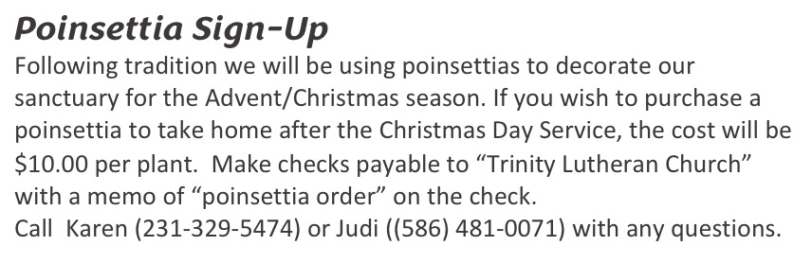

SERVING in GODS HOUSE NEXT SUNDAY DECEMBER 11
Pastor: Rev. Ken Bernthal
Elder: Ken Mertz
Ushers: Terry & Bill Stiles
Greeters: Tom & Terri Raithel
Altar Care: Nancy Ely
Counters: Wendall Smith, Karl Scheiterlein
Coffee Servers: LWML Carla Elenz, Kathy Erat
Organ/Piano: The Beaches
Children’s Talk: Nancy Ely
Children’s Sunday School: Sharon Techel, Jean Beach and Nancy Ely
Sunday Morning Bible Study: w/ Dr. Tom Beach

THIS WEEK AT TRINITY
December 4 Sunday
9:00 am Worship Service – Rev. Paul Schneider
10:00 am Fellowship & Coffee Hour
10:30 am Congregational Voters Meeting.
December 5 Monday
10:00 am Kut-Ups
7:00 pm Choir
December 6 Tuesday
10:30 am Elders Meeting
3:00 am Heart of the Pines Quilt Guild
5:00 pm Ladies Get Together Dinner
December 7 Wednesday
10:00 am Wednesday Morning Bible Study W/ Pastor Ken Bernthal
December 8 Thursday
7:00 pm LWML Planning @ Kathy Erat’s House
December 9 Friday
11:45 am Trinity works the Food Pantry (at United Way)
December 10 Saturday
December 11 Sunday
9:00 am Worship Service - Rev. Ken Bernthal
10:00 am Fellowship & Coffee Hour
10:30 am Bible Study with Dr. Tom Beach
10:30 am Children’s Sunday School

